2,118 views|Oct 15, 2020,11:12am EDT

States Should Reject Nonbank Regulations Proposed By The Conference Of State Bank Supervisors
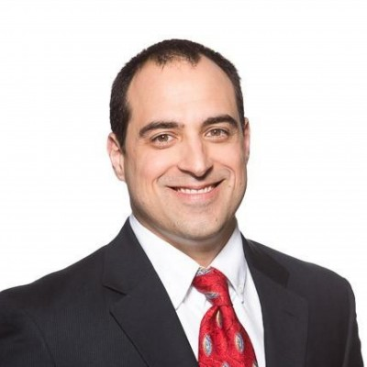
Norbert MichelContributor
Policy
I follow the evolution and devolution of monetary and financial policy

An empty mortgage application form with house key
GETTY
Last week, the Conference of State Bank Supervisors (CSBS) released a proposal to impose new regulations on the nonbank financial companies that service home mortgages. States should reject this approach for many reasons, least of which is that bank regulators should not have a major influence on regulating financial firms that are not banks.
The proposal recommends a host of new capital, liquidity, stress testing, and living-will requirements on mortgage servicers. Most of these rules resemble the prudential regulations forced on banks in the Dodd-Frank era, and many are harmful and counterproductive in their own right. Moreover, the CSBS proposal ignores the principle justification for these kinds of federal banking regulations: The federal government insures bank deposits.
Federal officials have long viewed banks as “special” because of this arrangement, and most banks have been happy to go along with the extensive regulations that come with it. Although it is probably not ideal, the relationship does dictate that the federal government should have something to do with monitoring the safety and soundness of the nation’s banks.
Recommended For You

Donald Trump Has At Least $1 Billion In Debt, More Than Twice The Amount He Suggested

Are Higher Taxes Coming? Three Things To Watch For

Antigua’s Passport May Be An Investor’s Ticket To Paradise

Of course, this special relationship does not exist with nonbank financial companies. The government has no interest in companies’ operating standards when taxpayers are not exposed to financial losses, and if the government chooses to provide bailouts to companies, then it makes little sense to punish those companies with regulations.
The fact that nonbank mortgage servicers are, as the CSBS argues, “an important segment of the financial services community” means essentially nothing. WalMart, Apple, Lowes, and Home Depot are integral to millions of people’s lives, but the government does not – and should not – impose financial safety and soundness standards on their operations.
PROMOTED
Japan BRANDVOICE | Paid Program

This Japan Startup Is Using Deep Learning To Detect Early-Stage Cancer In Blood Samples
Mitsubishi Heavy Industries BRANDVOICE | Paid Program

Oil & Gas Outlook – Embracing Change From Now To 2040
UNICEF USA BRANDVOICE | Paid Program

Community Health Workers Are Yemen’s Superheroes
Moreover, the fact that excessive regulation of banking firms was a primary cause of pushing such a high volume of mortgage servicing into the nonbank sector should give states pause. Following the lead of the CSBS – even if the CSBS is following the lead of the federal banking regulators who caused that exodus – makes even less sense given that recent turmoil in the servicing business is not due to the nature of the servicing business itself.
The servicing sector consists of companies that collect homeowners’ mortgage payments and pass them on to someone else, most frequently the FHA, Fannie Mae, or Freddie Mac. These three entities, in turn, pass those payments on to the people holding mortgage-backed securities (MBS). The servicers do not fund the mortgages, and they have nothing to do with the promises those funding entities made to MBS investors. The firms act as middlemen when they service loans.
In general, when a mortgage holder is late with a payment, the servicer is still responsible for passing those funds on. The details vary depending on who is supposed to receive those funds, but there are limits to these contractual obligations. (In fact, some servicing contracts do not require servicers to pass on any funds unless they receive the scheduled payment from the homeowner.)
In the case of Fannie and Freddie, for example, after 120 days the servicer typically no longer has to provide payments. If that loan is later foreclosed, the servicer is reimbursed for the funds that it advanced on the delinquent loan before the 120 day mark. This arrangement is, as it should be, between Fannie, Freddie, their regulator (the FHFA), and the servicers.
During the COVID-19 pandemic, Congress told homeowners that they have the right to stop paying their mortgages for at least 180 days (Section 4022 of the CARES Act) due to any hardships from the pandemic, but they made zero provisions to make those funds available to servicers.
And for roughly two-thirds of the mortgage market, a government-backed entity is already responsible for guaranteeing payments, regardless of who is servicing the loan. Congress created this mess, and it has nothing to do with things like liquidity requirements and stress testing at nonbank servicers.
It is also important to point out that states already regulate these nonbank companies – differently, depending on the business entity – so the relevant cost/benefit of implementing the CSBS proposal has to factor in the effectiveness of the existing framework. While this framework does not seem to have ever really broken down, the same cannot be said for a standardized regulatory regime imposed on the banking industry.
So there are many good reasons that states should reject the CSBS proposal.
Follow me on Twitter.
Norbert Michel
I am the Director of the Center for Data Analysis at The Heritage Foundation. I also research issues pertaining to financial markets and monetary policy.

